Example -05 SQL PRACTICE NOTES - PHYSICIAN & DEPARTMENT TABLES
2520030263
N. Madhan
DATABASE CREATION
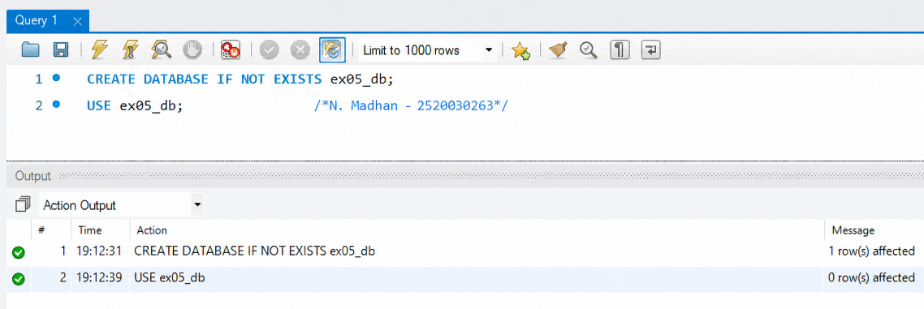

CREATE PHYSICIAN TABLE
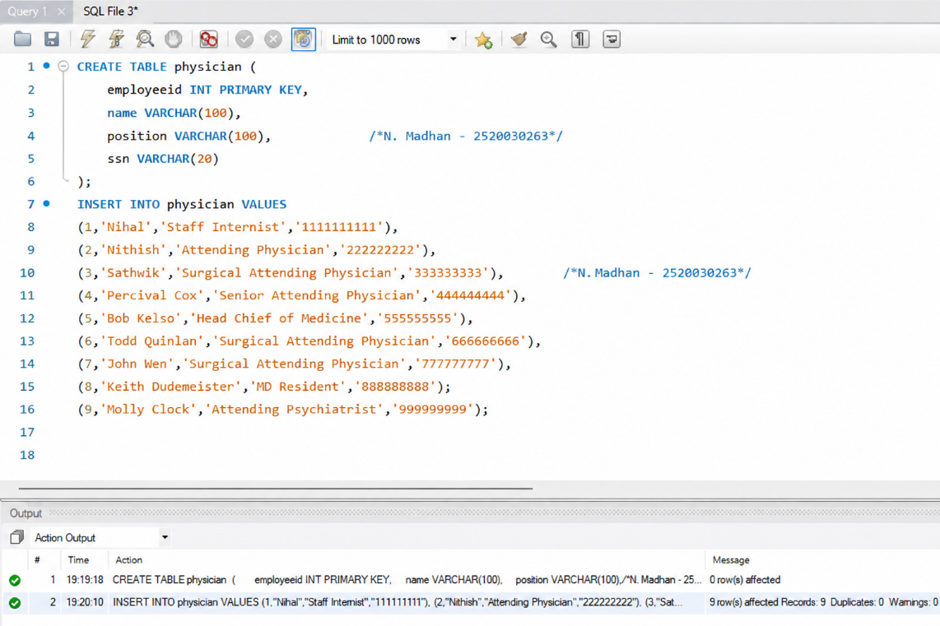

CREATE DEPARTMENT TABLE
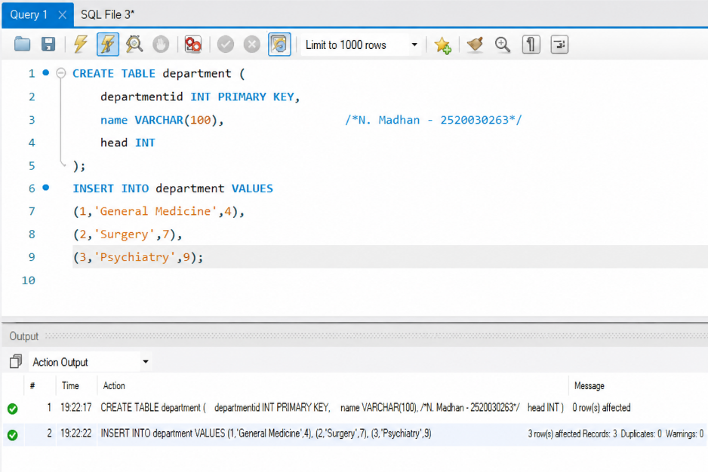

INNER JOIN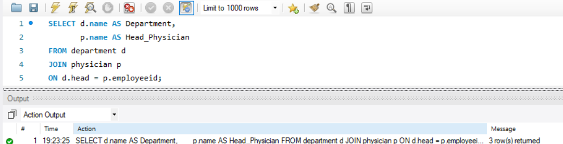

WHERE CLAUSE + WHERE LIKE + COUNT() 